SOPH³
Christmas Sundowner

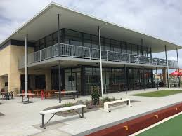
No Run… Just a Big On On

Thursday 17th December, 2020
Fremantle Park and Community Centre
36 Ellen St, Fremantle
https://www.freoparkcentre.com.au/

5:30 till …
Food available at great prices:
Thursday Night Dinner Specials $15
Happy Hour for cheap drinks Free parking available onsite
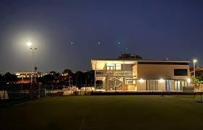

Join the SOPH³ hashers at the new social venue in Freo

